System overview
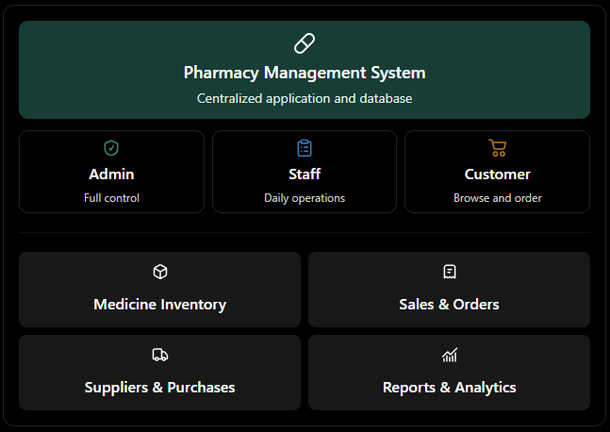

2. Role permissions

Feature | Admin | Staff | Customer
View dashboard | All statistics | Operational summary | Personal summary
Manage users | Yes | No | Manage own profile
Add/edit medicines | Yes | Authorized edits only | No
Manage stock | Yes | Yes | No
Manage suppliers | Yes | View/use as authorized | No
Purchase medicines from suppliers | Yes | Yes, if authorized | No
Sell medicines | Yes | Yes | No
Browse medicine catalog | Yes | Yes | Yes
Place customer orders | Yes | Manage orders | Yes
View sales reports | All reports | Limited reports | Own orders
Manage system settings | Yes | No | No

Database design
A. User and access management
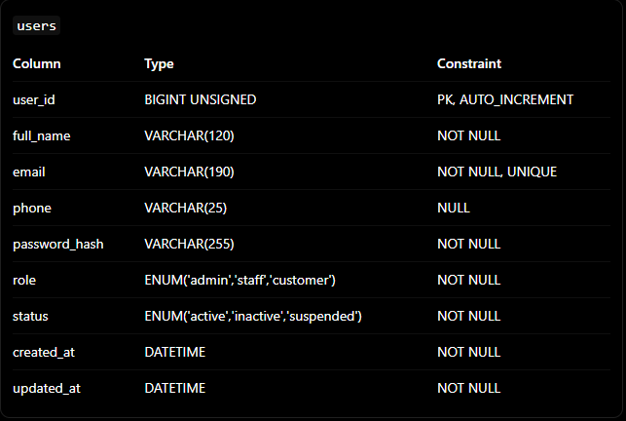

Admin profile: admin_profiles
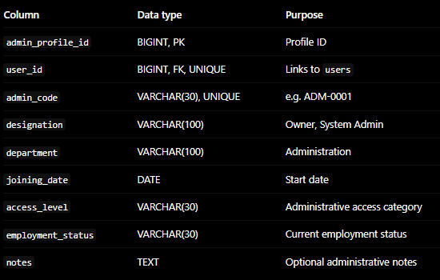

Staff profile: staff_profiles
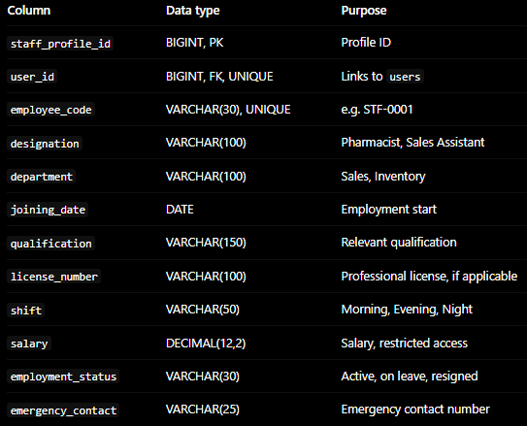

Customer profile: customer_profiles
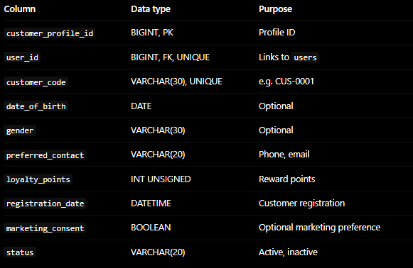

B. Medicine catalog
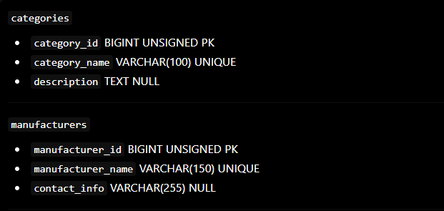
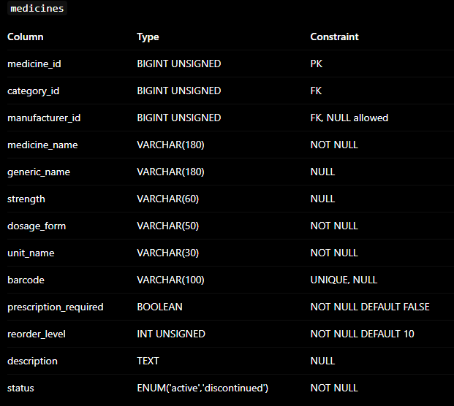

C. Suppliers and purchases
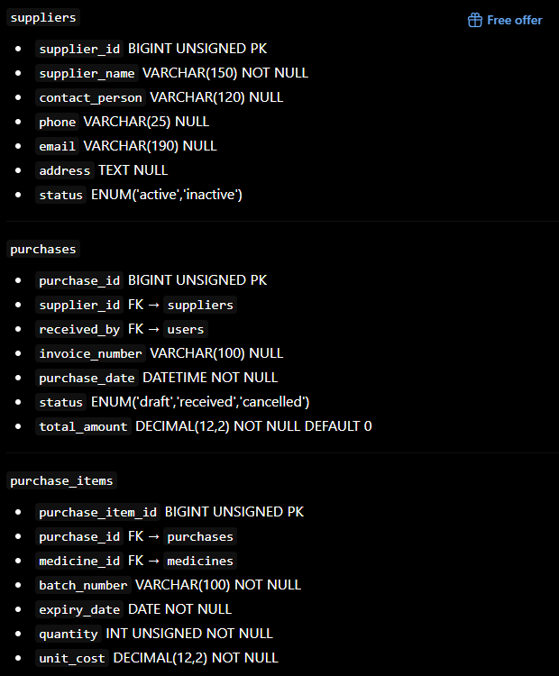

D. Batch-level inventory
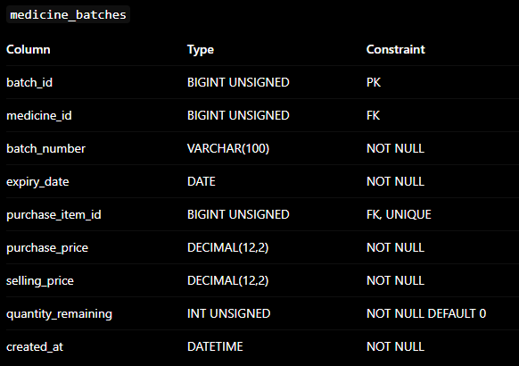

E. Sales and in-store transactions
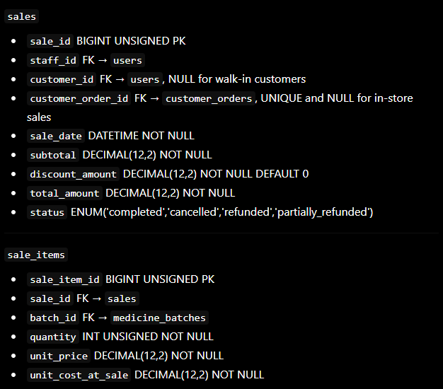

F. Online customer ordering
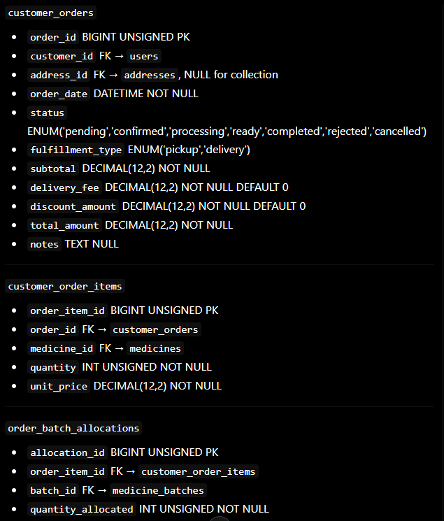

G. Payments
